

CP5046 ICT Phase - 2

Assessment TASK 1: Cycle Report

**Lecturer: Laura Antochi**

**Team Members:**

Anastasia Verchak ID: 13446694

Charanpreet Kaur ID: 13543377

Harshitha Paderu ID: 13539782

Rajendra Manandhar ID:

## Roles and Contributions:

|  |  |  |
| --- | --- | --- |
| **Name** | **Project role(s)** | **Individual contributions** |
| Anastasia Verchak | Project manager, tester | * Client agreement * Prototypes * Communication with the client * White box testing * Project management tools * Documentation * Client testing acceptation form * Client acceptation form * Front end design * Moodle developing |
| Charanpreet Kaur | Front-End Developer | * Configuration management   - Front-end development |
| Harshitha Paderu | Back-End Developer | * Burn down and velocity charts * Steps for new member to setup database and hosting environment * Development tools - phpmyadmin, hosting environment - WinSCP   - Back end development  - Documentation Proof-reading and editing |
| Rajendra Manandhar | Front-  End Developer | * Front-end developing * Bugs fixing |

According to the results of Beta release, new Final plan had been created and accepted by the both sides.

Romashka is a fully functional web based application designed to fulfill the needs of the Russian Language School located at 6 Lawson Street, Southport, Queensland. This web application allows users (Students and Staff) to sign up into the student portal designed for intuitive teaching and learning process where they can see the subjects they have been enrolled, edit and update their profile, upload assignments and check the similarities between the students to avoid plagiarism with the help of online portal named Moodle. Apart from this there will be an admin portal where the admin of the Romashka Russian Language School can logged in with given credentials. Admin will have its own dashboard where admin can see the details of students, teachers, subjects as well as flexibility of adding new staff members (teachers) and subjects as per the needs of the school.

Alpha version of Romashka was released in ICT 1 where some of the webpages were completed like Home Page, login and Registration. There were some issues regarding the user interface of the web application which we were unable to be fixed because of the time limitation.

The beta iterations as planned earlier are listed below:

**Beta release proposal**

According to the results of Alpha release, new Beta plan had been created and accepted by the both sides.

|  |  |  |  |
| --- | --- | --- | --- |
| Title | Description | Client Priority | Time estimate (days) |
| Bug fixing | See AlphaTestReport.pdf | 10 | 5 |
| Confirmation page | presents the total amount to be paid | 20 | 5 |
| Payment page | process the payment | 20 | 5 |
| Subject Selection page | Students can enroll by choosing the subjects for the first time and confirm their enrollment | 20 | 5 |
| Edit Selection page | Edit the choices of subjects (withdrawing, changing of subjects) | 20 | 5 |
| Dashboard | Student has an access to his study activities | 10 | 5 |
| Contact us page | Access to the contact details of the school to find its location, phone number for any queries. | 20 | 2 |
| Why we page | Access to the information about the school involving teaching programs, events,etc. | 20 | 5 |

# Actual Beta release

|  |  |  |  |
| --- | --- | --- | --- |
| Title | Description | Client Priority | Time estimate (days) |
| Bug fixing | See AlphaTestReport.pdf | 10 | 5 |
| Enrollment | As an Admin, I want to enrol students to the subject so that a student could study | 10 | 3 |
| Creating a user | As an Admin, I want to create a user so that a student or a teacher could have an access to the Moodle | 10 | 3 |
| Creating a subject | As an Admin, I want to create a new subject so that a student could study that subject in the future | 10 | 3 |
| Assign role to a user | As an Admin, I want to assign role (student, teacher) to a user so that the website would be protected | 10 | 3 |
| Subject Selection page | Students can enroll by choosing the subjects for the first time and confirm their enrollment | 20 | 5 |
| Edit Selection page | Edit the choices of subjects (withdrawing, changing of subjects) | 20 | 5 |
| Dashboard | Student has an access to his study activities | 10 | 5 |
| Contact us page | Access to the contact details of the school to find its location, phone number for any queries. | 20 | 2 |
| Why we page | Access to the information about the school involving teaching programs, events,etc. | 20 | 5 |

As software development life cycle is Agile we need to adapt with changes because client’s requirement changes time to time. As planned for the beta release of Romashka we had fixed the bugs that we encountered in our alpha version and made major changes in the web application as well. The header, navigation bar, footer, login and registration page of the website have been changed as the clients request. For beta release we completed the front end design of the user profile dashboard (supported by Moodle), Contact Us Page and Why us page.

The subject selection page and payment page were postponed to final release of our project Romashka because the client has given less priority to those pages. Also, for our final release of the web application we will be creating the admin panel which gives flexibility to admin to add staff members and subject as per needs of the school as well as assigning subjects to the teachers so that suitable experienced teachers are

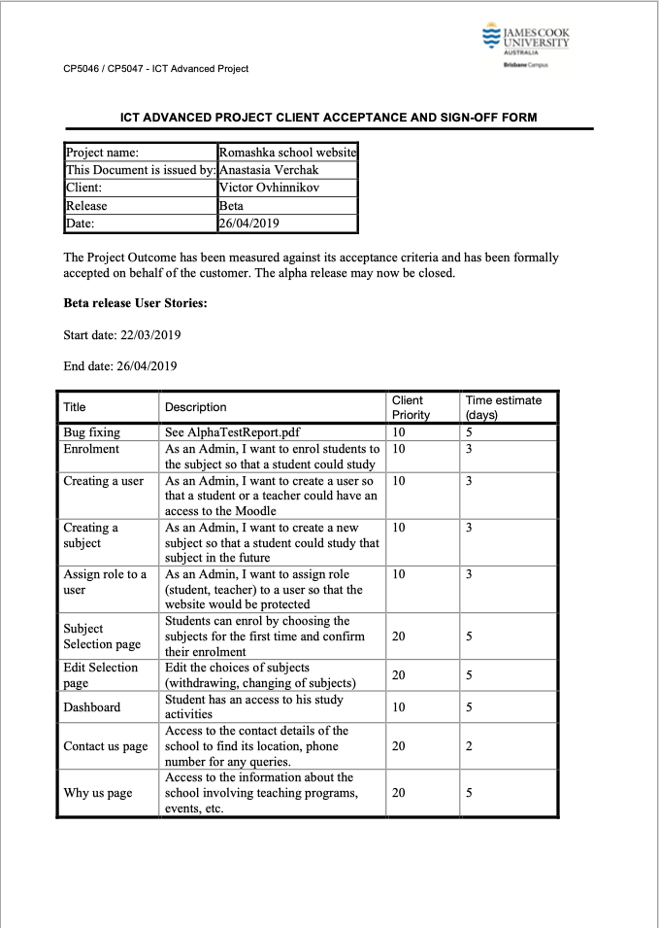assigned to attend and teach the subjects to enhance the teaching and learning process for students.

The Screenshots of the web pages of the beta release are presented further in this report.

**Client signed acceptance of the BETA-release**

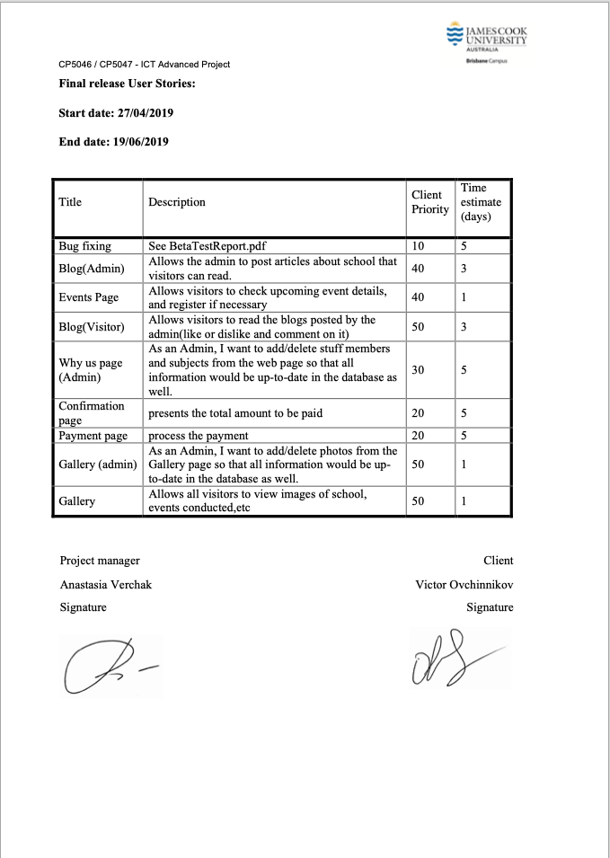

# Final-release

|  |  |  |  |
| --- | --- | --- | --- |
| **Title** | **Description** | **Client Priority** | **Time estimate (days)** |
| Bug fixing | See BetaTestReport.pdf | 10 | 5 |
| Blog(Admin) | Allows the admin to post articles about school that visitors can read. | 40 | 3 |
| Events Page | Allows visitors to check upcoming event details, and register if necessary | 40 | 1 |
| Blog(Visitor) | Allows visitors to read the blogs posted by the admin(like or dislike and comment on it) | 50 | 3 |
| Why we page (Admin) | As an Admin, I want to add/delete stuff members and subjects from the web page so that all information would be up-to-date in the database as well. | 30 | 5 |
| Confirmation page | Presents the total amount to be paid | 20 | 5 |
| Payment page | Process the payment | 20 | 5 |
| Gallery (admin) | As an Admin, I want to add/delete photos from the Gallery page so that all information would be up-to-date in the database as well. | 50 | 1 |
| Gallery | Allows all visitors to view images of school, events conducted,etc | 50 | 1 |

# Client testing:

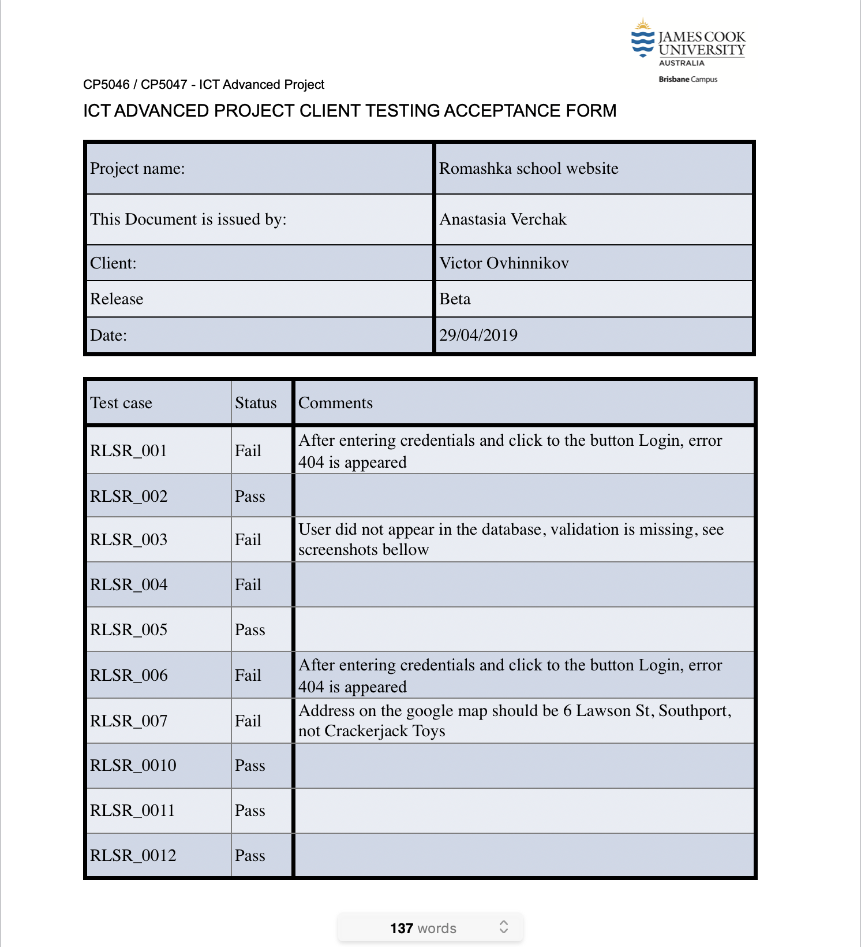

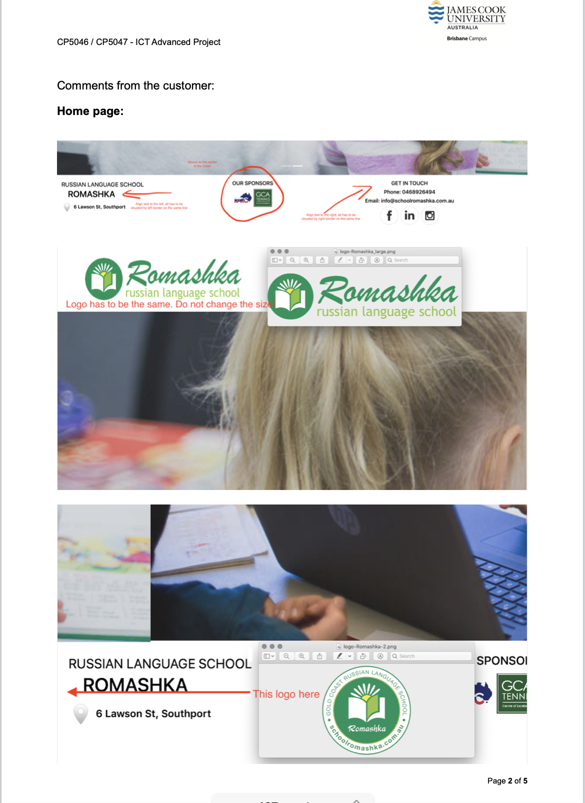

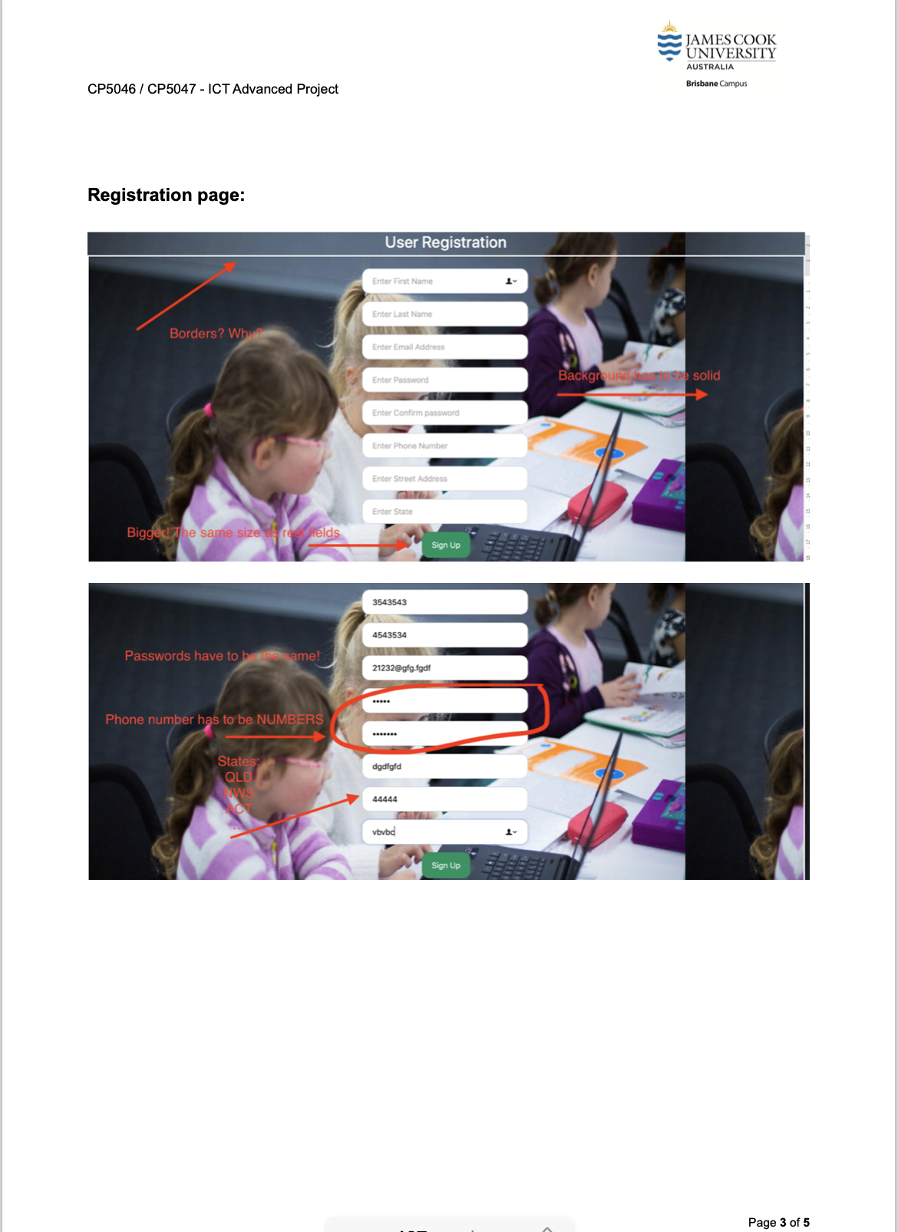

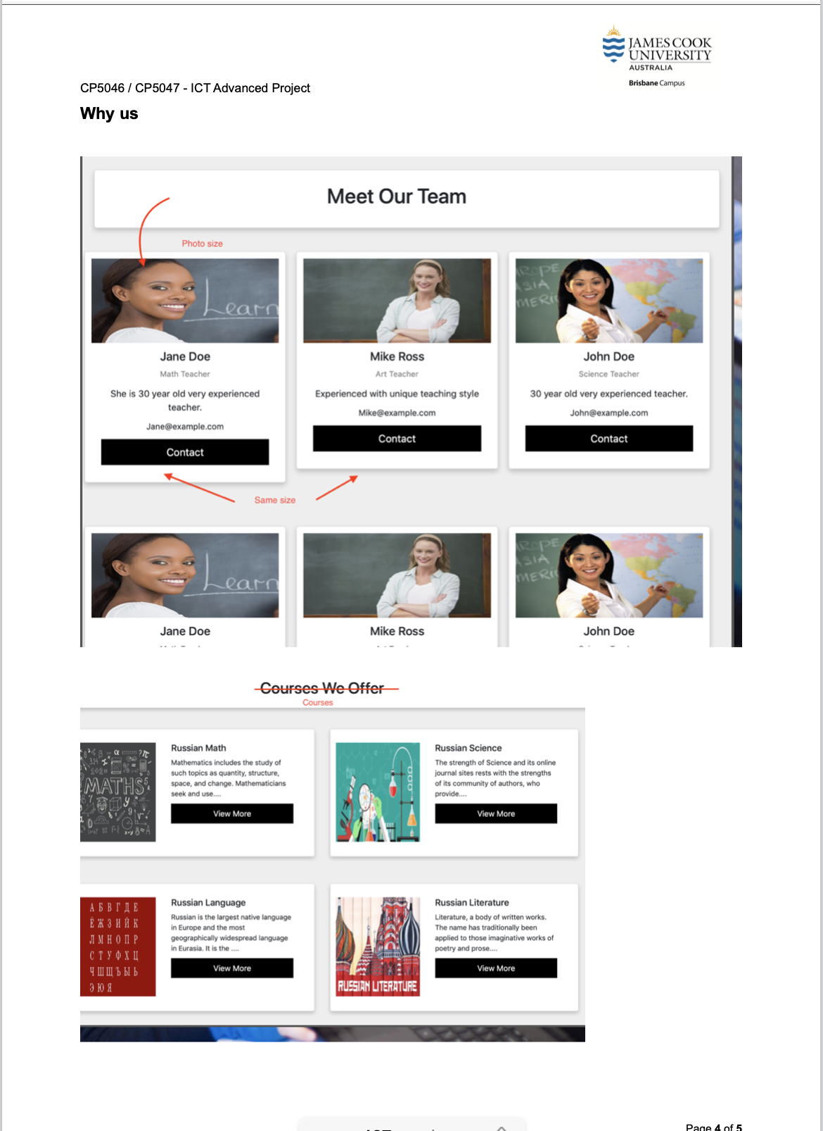

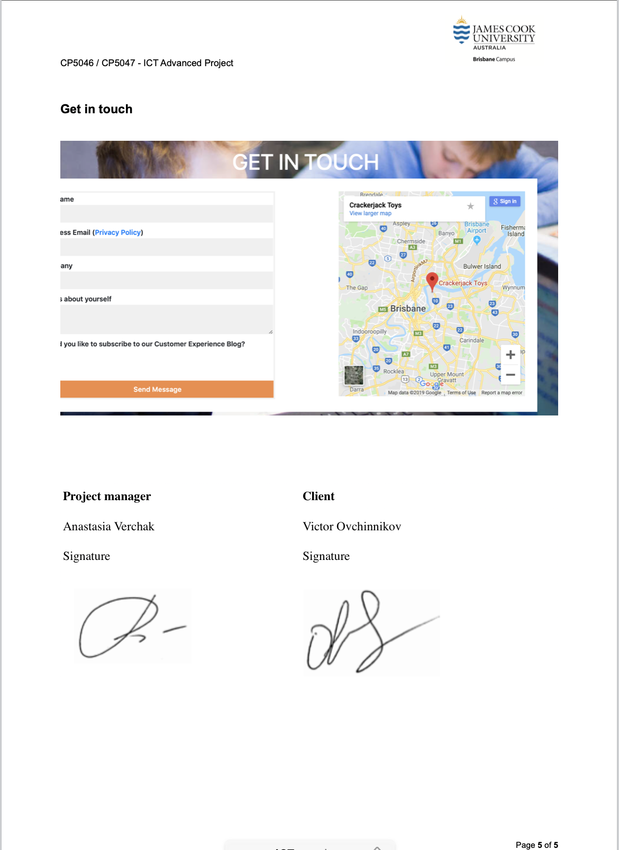

# Demonstration of the Beta release

|  |
| --- |
| Enrolment |
|  |
| Creating a user |
|  |
| Creating a subject |
|  |
| Assign role to a user |
|  |
| Subject Selection page |
|  |
| Edit Selection page |
|  |
| Dashboard |
|  |
| Contact us page |
|  |
| Why we page |
|  |
|  |

## Final release prototypes:

|  |
| --- |
| Blog |
|  |
|  |
| Events Page |
|  |
| Confirmation page |
|  |
| Payment page |
|  |
| Gallery |
|  |

**ICT Infrastructure**

**Configuration management**

**Server and Domain**

|  |  |
| --- | --- |
| **Subdomain:** | [romashka.ictatjcub.com](http://romashka.ictatjcub.com/)/Romashka |
| **FTP host:** | [ftp.ictatjcub.com](http://ftp.ictatjcub.com/) |
| **FTP username:** | [romashka@ictatjcub.com](mailto:romashka@ictatjcub.com) |
| **FTP password:** | 123zxcA! |
| **Remote phpMyAdmin:** | [romashka.ictatjcub.com/phpmyadmin](http://romashka.ictatjcub.com/phpmyadmin) |
| **Database name:** | ictatjcu_romashka |
| **Database host:** | localhost |
| **Database user:** | ictatjcu_romashk |
| **Database password:** | 123zxc |
| **Moodle:** | <http://romashka.ictatjcub.com/moodle> |
| **Moodle database:** | ictatjcu_moodle |
| **Moodle database password:** | 123zxc |
| **Moodle database user:** | ictatjcu_moodle |
| **Moodle admin:** | Admin |
| **Moodle admin password** | 123Zxc456! |

|  |
| --- |
| GitHub is an online version control service which stores our work in versioned fashion. We can revert to any version at any point in time. Multiple users can use a repository to store their work. |
| Link to the repository is as follow:  <https://github.com/harshup96/Romashka> |
| Picture 11 |
| Picture 13 |
| It is a comprehensive tool developed by Adobe for web designers. We used Dreamweaver for designing our HTML and CSS pages. The integration with Git makes it flawless. It also supports JavaScript, PhP. |
| PHP is a server-side scripting language that is embedded in HTML. It is integrated with number of popular databases like MySQL, Oracle, PostgreSQL, Informix, etc. |
| NEW DATABASE SCREENSHOTS (phpmyadmin) |
| Picture 1 |
| Moodle Database |
| Picture 15 |
| **HTML and CSS:** |
| HTML stands for Hypertext Markup Language. It supports tags for various elements of a web page. |
| pasted-image.png |
| **pasted-image.png** |
| **pasted-image.png** |
| ** If a new team member adds up in later phases, they have to install Dreamweaver, Accessnon their laptops. The previously developed versions can be found on GitHub. The new team member should understand our progress and be able to learn the programming needed. He/she should be able to understand the user stories and priorities. |

**THE DATABASE:**

The remote database for this project is located at ‘romashka.ictatjcub.com/phpmyadmin’.

phpMyAdmin is an open source toll that provides a Graphical User Interface to work with the MySQL database management system in case of this project. With phpMyAdmin, the admin can create, alter or drop databases and tables, create or remove users and user accounts, manage the privileges granted to a particular user, import and export data in SQL and other formats, etc.

For this project, a Database named ‘ictatjcu_romashka’ was created. The Username is ‘ictatjcu_romashk’ and Password is ‘123zxc’. Knowledge of these credentials are sufficient for existing members of the team and any plausible new members who may join the team.

Steps for set-up of Database:

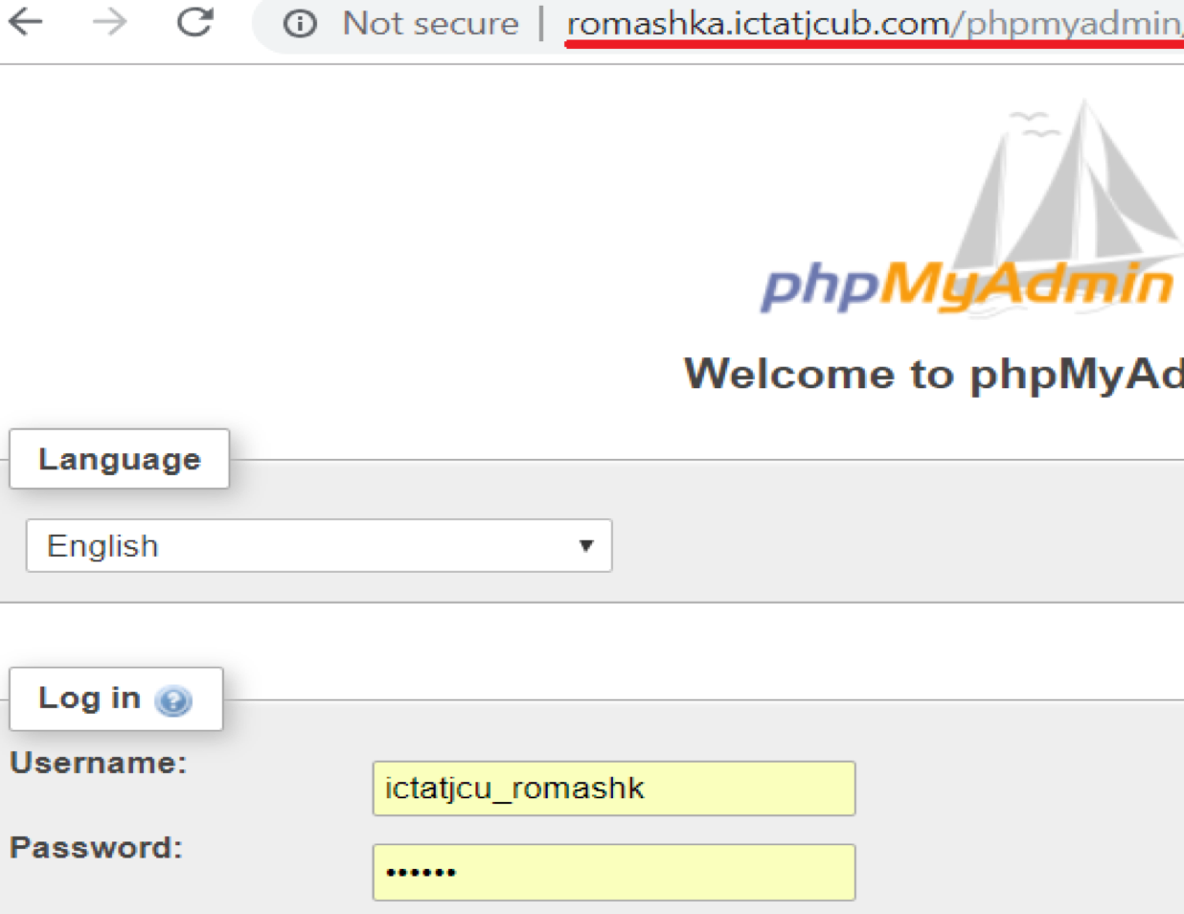**Step 1: Login**

**Step 2: Create Tables and Insert Data (Since Database is already created)**

Tables can be created using SQL or by clicking on the ‘+New’ button on the left hand side.

Similarly, data can be inserted using the Insert tab or by writing an SQL, or my Importing or Exporting from other existing databases, or Excel files.

The Table Columns and data can be seen or edited by selecting the respective table on the side bar. Also, the Primary keys, foreign keys, indexes and relationships can be updated under the ‘Designer’ tab.

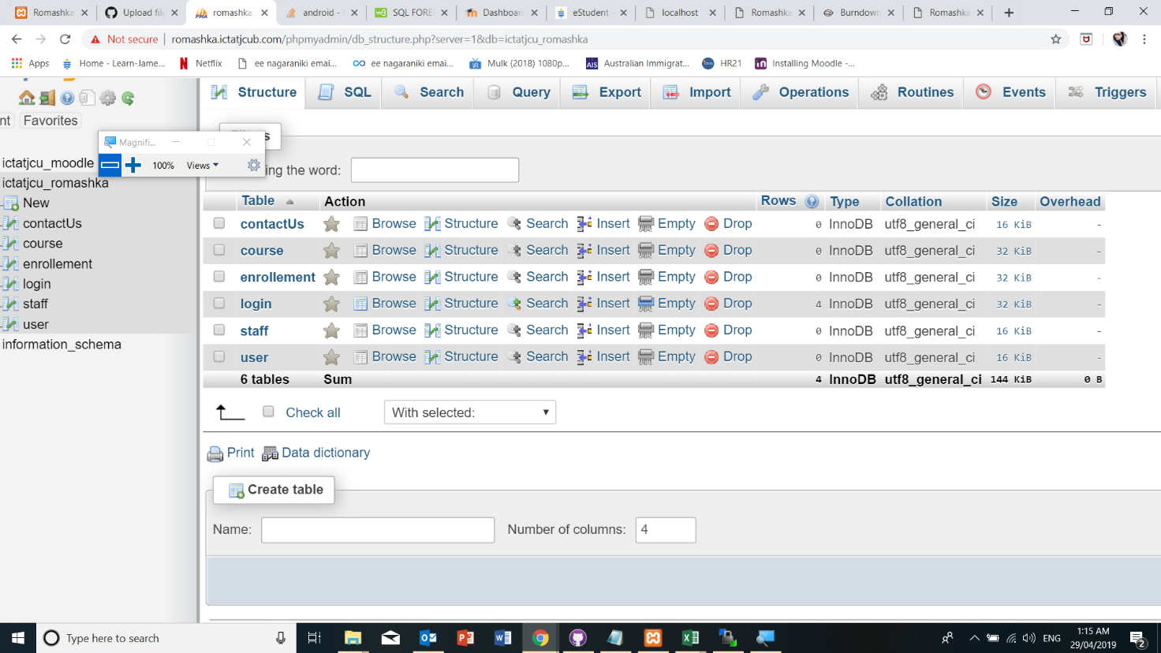

**Step 3: Creating a connection with the database.**

A config.php file contains the php code to enables connection with the database, is included in the <?php> .. ?> section of all the .php files created in the front end of the project.

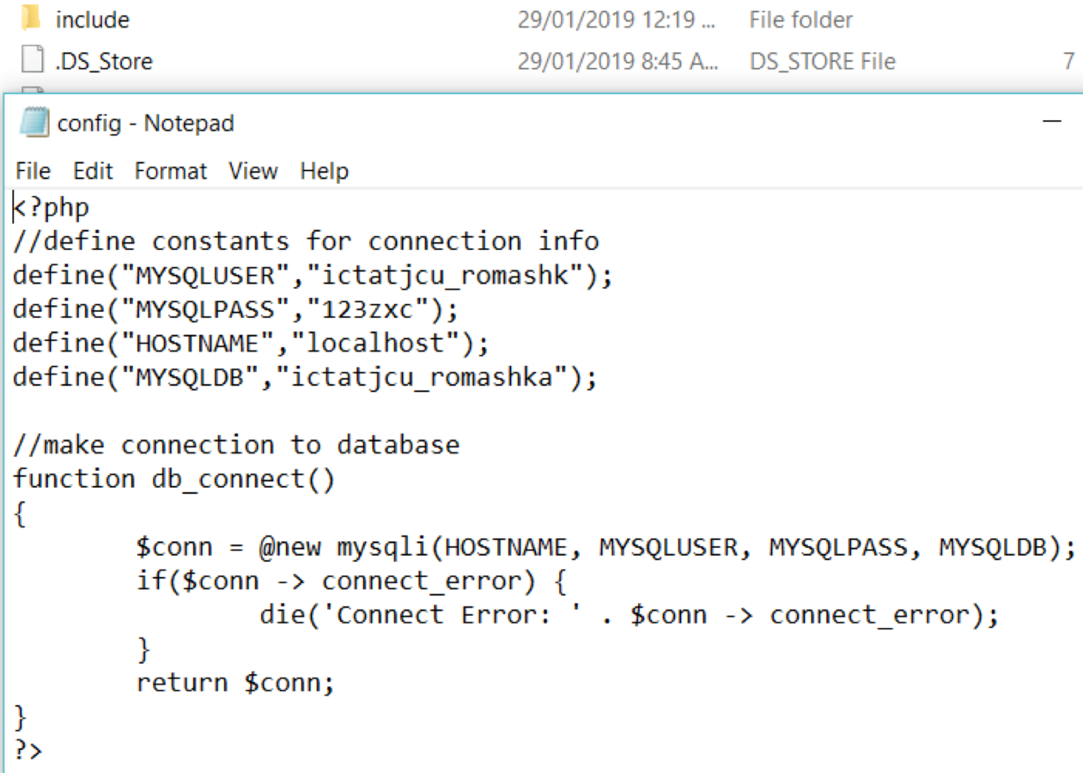

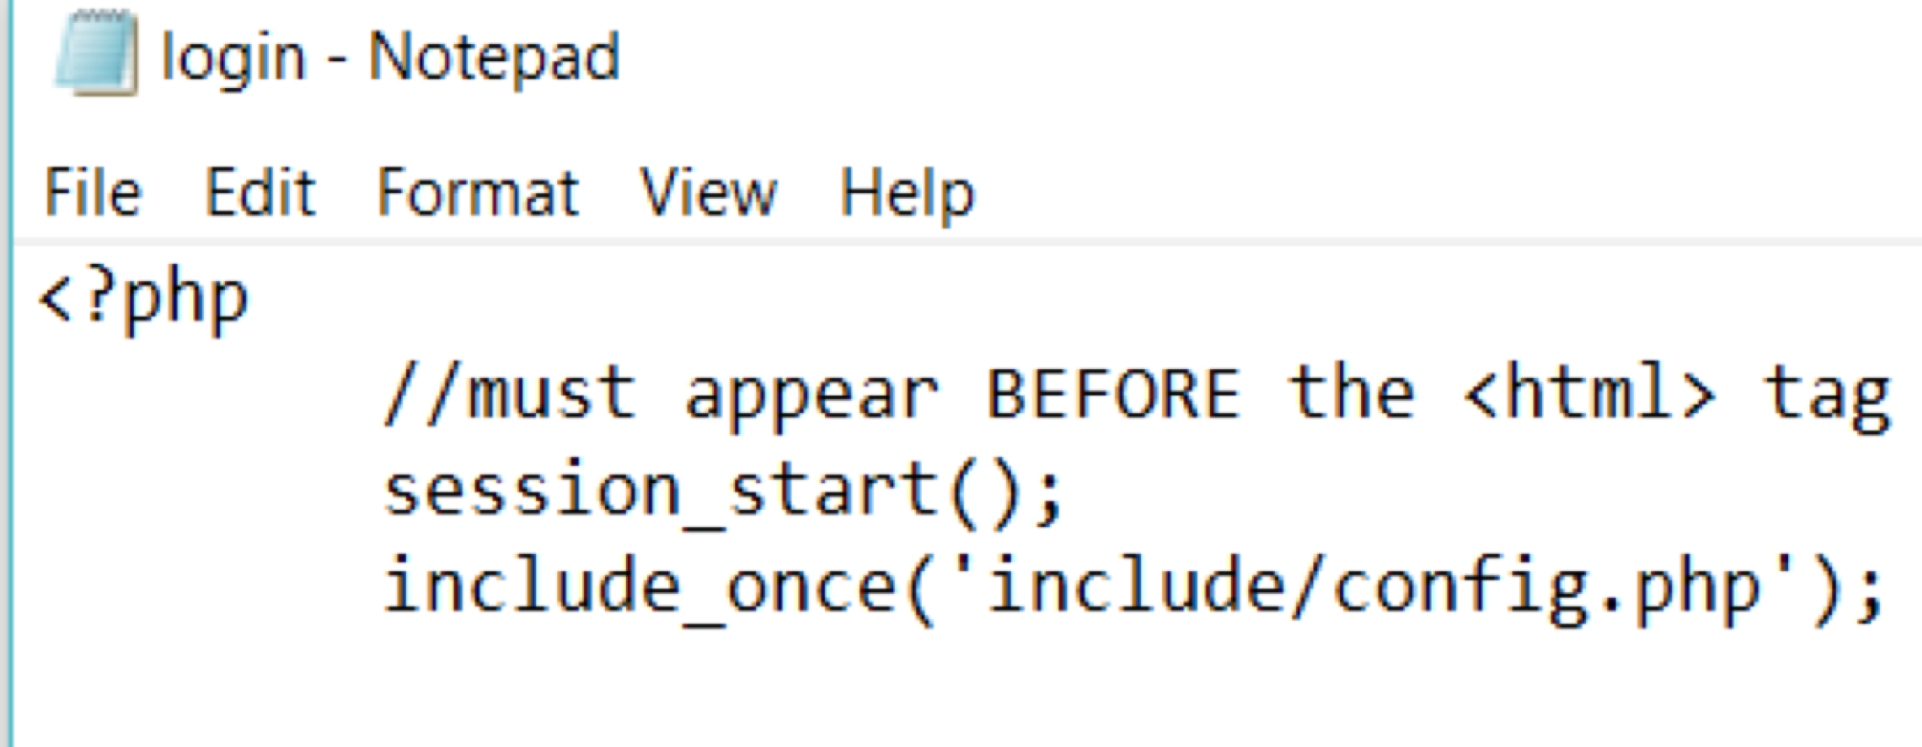

Once the connection is established, suitable php code is inserted in the dynamic pages of the site to for validation and other functionality.

An Example of the Registration.php code is as follows:

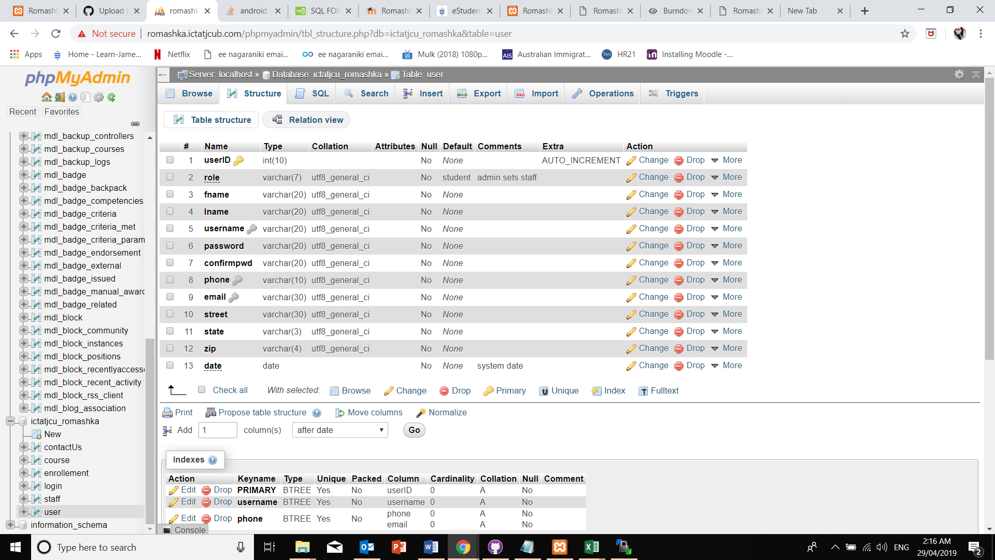

**THE RELEASE ENVIRONMENT**

The Release Environment chosen for this project is ‘WinSCP’. It is an open source FTP client, SFTP client, SCP client, etc. for Windows OS. Its main functionality is File Transfer between a local and a remote computer.

It provides a GUI and is integrated with Windows to provide basic operations with files and drag & drop facilities. For this project, its support with FTP protocols is utilised. It is faster compared to other hosting environments.

How to set-up the environment:

**Step 1:**

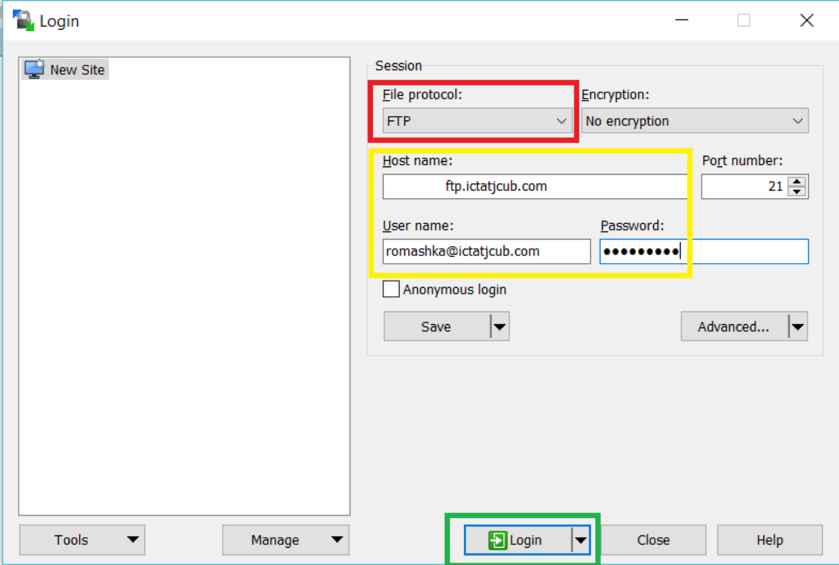

On launching WinSCP after installation, it prompts us to login.

We use the hostname, host username and host password as the credentials to login, but before that, the File Protocol must be set to FTP.

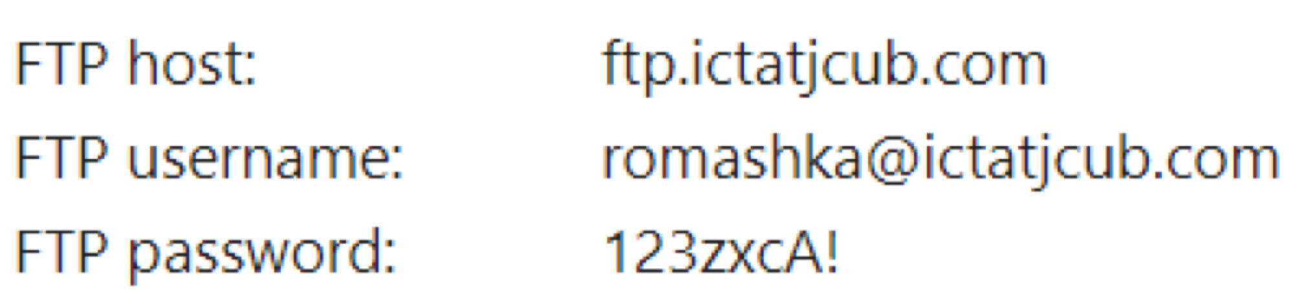

For this project, the host credentials are as under:

When this dialogue box pops-up, it means the connection is getting established, and if successful the session is started.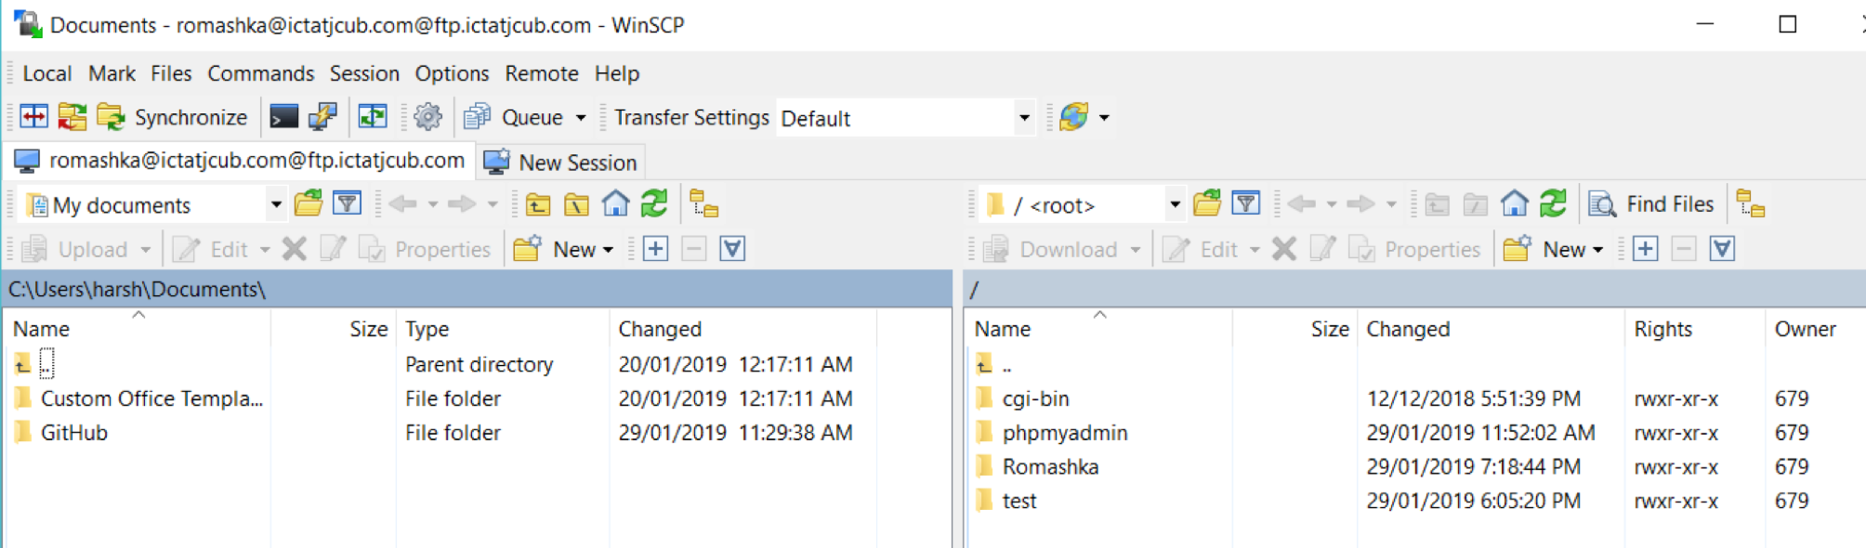

On the left-hand side are the files of the local computer and on the right-hand side are the files on the remote computer.

**Step 2: Perform File Transfer**

The files of the website are all place in a folder name ‘Romashka’. We can simply drag these files from the left hand side of the screen (local PC) and drop them into the right-hand side, the remote computer.

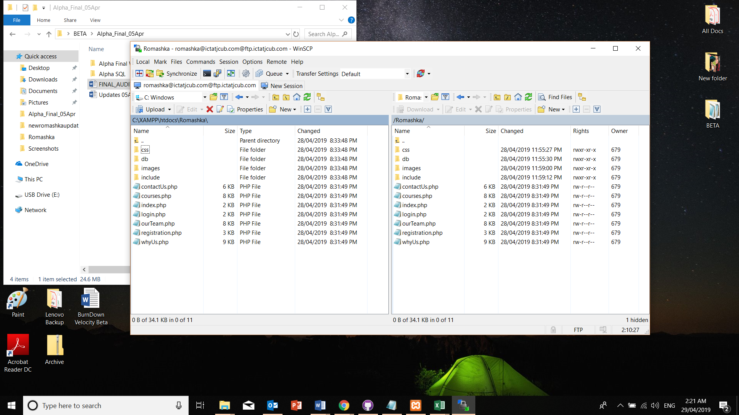

**Step 3: Ready for the Client to test**

The files or the website is now on the remote server and can be tested by the client.

The URL for the client to go to the website is: <http://romashka.ictatjcub.com/Romashka/index.html> or simply [http://romashka.ictatjcub.com/Romashka](http://romashka.ictatjcub.com/Romas), because the hosting environment is configured to look for index files from the folder and run them automatically.

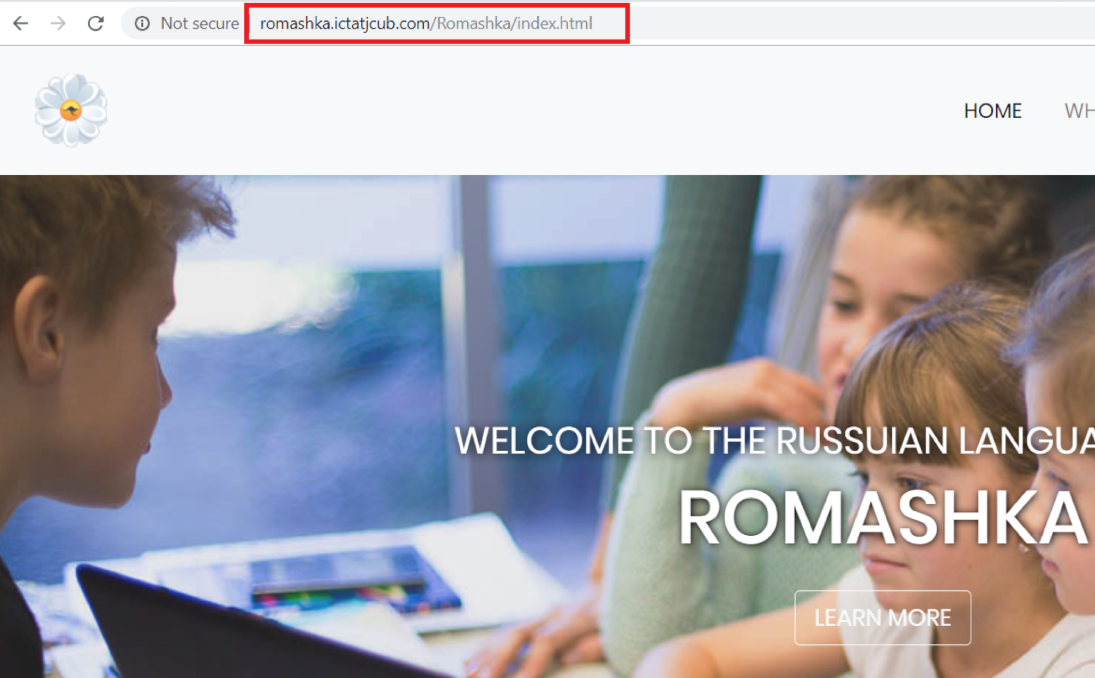

Any changes to the files can me made locally and re-uploaded to the remote hosting environment with no hustle.

Sometimes, due to inactivity or shutting down of the local PC, WinSCP logs out automatically for security purposes and in such cases, a login is necessary and the work can be picked up from where it was last left.

**PROJECT MANAGEMENT TOOLS**

Project management - it is the process of achieving a particular goal within a given framework (time, budget, etc.). At the same time, the concept of PM also includes a set of tools, techniques, skills and techniques that are used to achieve the goal and can vary depending on the changing conditions in which the work is carried out (the appearance of both risks and opportunities).

**Trello**

Trello is a web-based collaboration service that can help organise and manage projects using cards.  
The main advantage of Trello can be called viewing several simultaneously running projects and their status at the moment. To work with a group of developers or other artists working on projects with deadlines or goals, this system can give an idea of the progress of projects.

In Trello, the emphasis is on packs of cards. Each pack shows the status of any project. For example, if select a team to work, then in the first column there will be cards with a things which has to be done, in the second - tasks in progress, in the third there may be ready tasks, in the fourth - meetings and other general things.  
Cards have many features. They are intended for discussions, polls, download files and data. It is possible to set deadlines, assign text and color labels. To assign an executer to any task, it is necessary to select it in the card from the list of work team or simply drag the executer’s avatar to the task on the right.  
It is important to note that all team members see changes in real time and can monitor the status of individual executers — online or offline.  
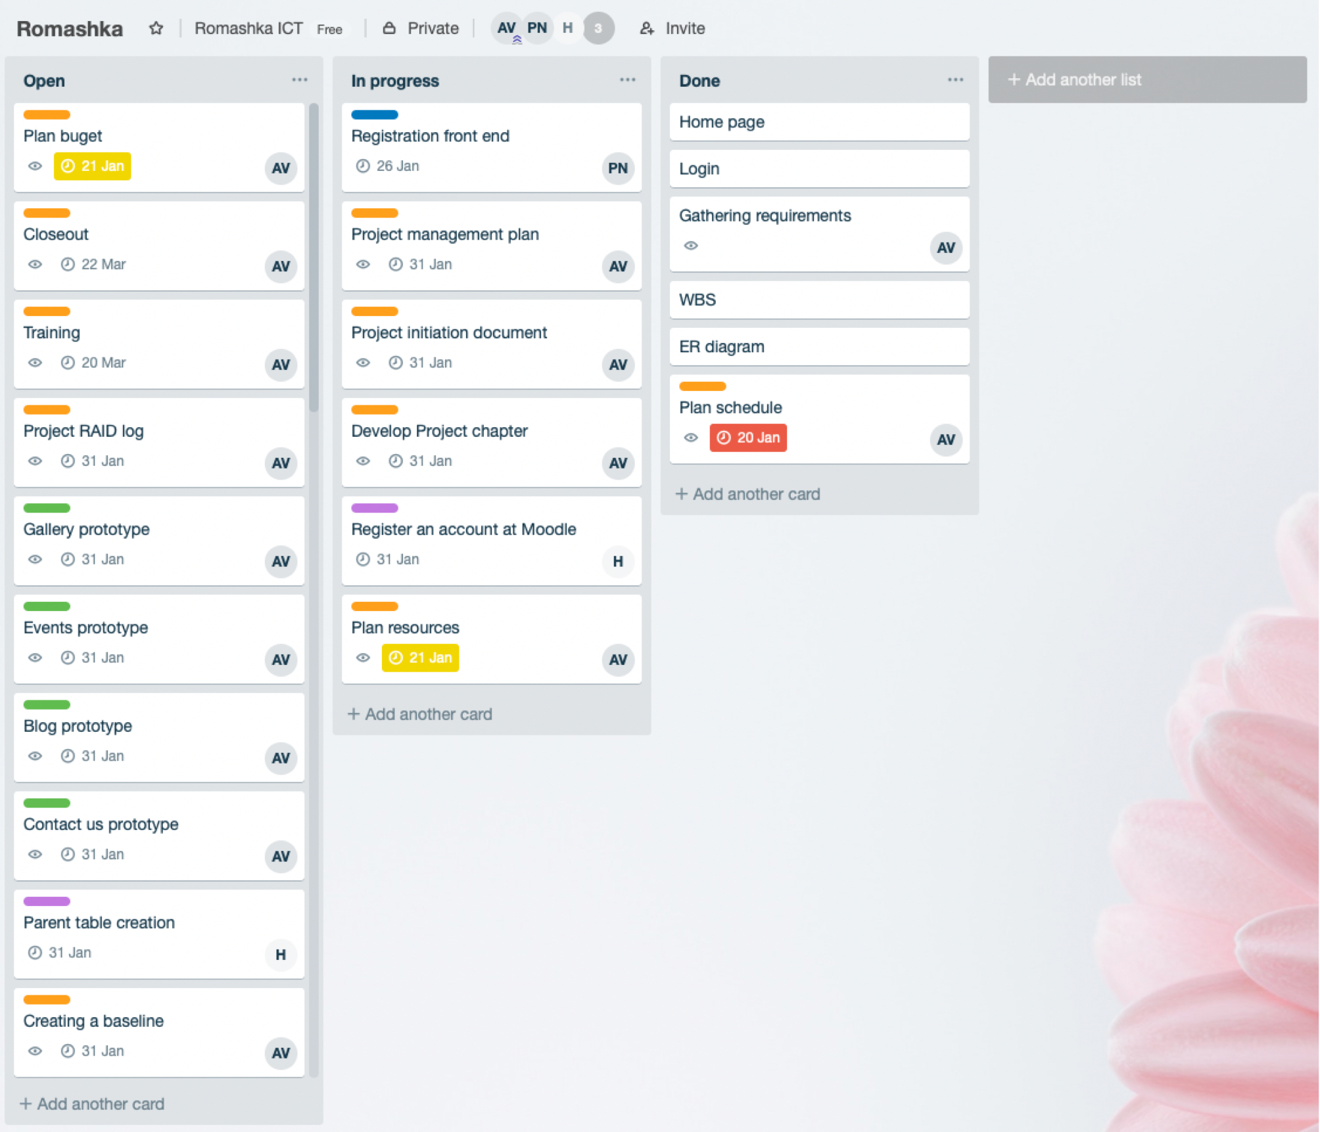Trello is available both in the web interface and as an application for the iPhone. On the iPad, the service works similarly to a desktop implementation.

**Slack**

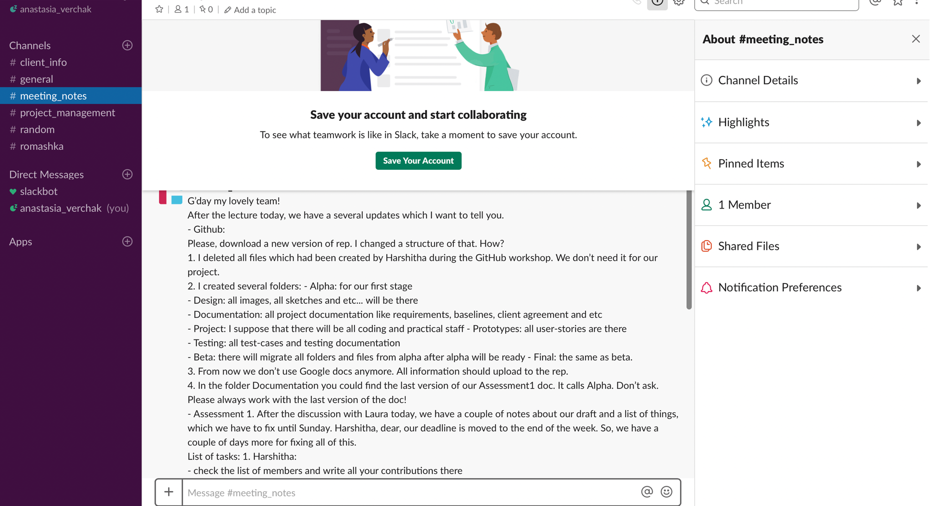Slack is an online service for correspondence within the team and a large company, but in fact it is a replacement for Skype for such conversations. This service has the ability to closely integrate active dialogs with other applications. This principle allows you to monitor the progress of work on various projects using one interface and remove unnecessary information.

**GanttPro**

GanttPro - Gantt chart that allows project manager to plan and manage projects online, visualise processes, create tasks and assign them to participants, set deadlines and percentage of individual tasks and the project as a whole, add milestones and share the created Gantt schedule with the team and with clients with the right to view or edit.

**BURNDOWN CHART AND VELOCITY CHARTS**

**THE BURNDOWN CHART:**

The Burndown chart was used to track the progress of the project that is now in full swing.

This chart represents the progress for the Beta Release of this project and the analysis will also help in managing the progress of the Final Release.

In this chart, on the X-Axis are the Number of Days that were allocated to all the User Stories that were planned in Beta, which was 42. And on the Y-Axis are typically the User Stories (or the work that had to be done) to get to the completion of Beta Release.

The User Stories that were to be completed (includes fixing the bugs from Alpha) and the days allocated in Beta are shown in the table below:

|  |  |  |
| --- | --- | --- |
| **Beta User Stories** | **Days Allocated** | **Status** |
| Bug Fixing (Includes Registration, Login, Header, Footer) | 15 | Completed |
| Moodle | 15 | Completed |
| Contact Us | 2 | Completed |
| About Us/Why us | 5 | Completed |
| Database Modification | 5 | Completed |

All the alterations that were made to Beta were successfully met, but new user stories were added to the Final release (admin pages) along with collaboration of the backend with the database created for Moodle.

As a result of migrating to moodle, and adding the admin pages to the project, accompanied to changes requested by the client, the completion to Beta release took longer than expected.

This lag is represented by the blue line (Actual) in the Burndown Chart.

For the Final Release, it is planned to keep the blue line (Actual) under the orange line (Estimated) and get back on track with the project!

**VELOCITY CHART:**

The Velocity Chart was a means by which the teams’ velocity or pace during the Beta Release was measured in order to track progress.

Beta Release took six weeks for completion and is represented on the X-Axis. The achievement of work is shown on the Y-Axis. The pace of the team is found to be constant during the first four weeks, as it was planned that the team members would work an average of 2.5 days in a week and about 5 hours a day. But during the last two weeks the pace increases in order to meet the client testing deadline.

In Beta, there were 3 User Stories, Migration to Moodle and Bug Fixing from Alpha, to be Completed over a total time span of 42 days. But, only tasks that were to be completed within 37 days could be delivered promptly.

The Formula for calculating the velocity of the team is:

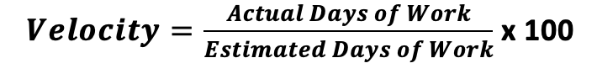

Therefore the velocity of this team is (37/42)*100 = **88.095%**

The Velocity rate achieved is visually very ambitious, but the fact of the matter is that, the major part of the project development has been pushed to the Final release and it could be a challenge to achieve a similar velocity rate.

